

Prepared for
Waseem Rauf

Prepared by
22k4748Hamza Yousuf
2k4785Shaiq hussain
22k4782Mavia mehmood

Project Title
Virtual class network

DATE
May 12, 2024
Project Report: Virtual Class Network

Executive Summary
This report outlines the development and implementation of a Virtual Class Network that integrates an administrative network with two distinct classroom networks. The setup utilizes advanced network protocols and services, including RIP routing, subnetting, and Secure Shell (SSH), DHCP for dynamic IP management and SMTP for email services. for remote access, to create a secure and efficient educational networking environment.

Project Objective
The primary goal of this project is to establish a robust virtual network that simulates a real-world educational setting. The network supports administrative tasks and facilitates a dynamic learning environment through segregated but interconnected network segments.

Network Design
The network is designed with a central router connecting the administrative segment to two classroom networks. This design allows for centralized management and efficient distribution of network resources.

Components:
One Main Router: Facilitates communication between the three network segments.
Admin Network: Includes a router, servers and administrative workstations.
Classroom Networks: Each classroom network includes a router, hosts multiple PCs and educational servers.
IP Addressing and Subnetting Scheme
The network employs a structured IP addressing and subnetting scheme to maximize efficiency:

Admin Network: 192.168.12.0/29, supporting up to 6 hosts.
Classroom One Network: 192.168.1.0/27, allowing up to 30 hosts.
Classroom Two Network: 192.168.2.0/27, also supporting up to 30 hosts.
Network Protocols and Services

DHCP (Dynamic Host Configuration Protocol): Automatically assigns IP addresses to devices within the admin and classroom networks, reducing manual configurations and supporting flexible, dynamic network changes.
SMTP (Simple Mail Transfer Protocol): Enables reliable email communication between the admin network and the classrooms, facilitating document sharing, notifications, and administrative communications.
RIP Routing: Used to facilitate dynamic routing between the network segments. RIP was chosen for its simplicity and adequacy for smaller networks.
SSH: Configured on all network devices to ensure secure administrative access. SSH replaces less secure access protocols like Telnet.
Subnetting: Each network segment is carefully subnetted to optimize the use of IP addresses and to segregate traffic effectively.
Testing and Evaluation
The network underwent rigorous testing to ensure functionality and security:

Connectivity Testing: Using ping and traceroute to confirm all nodes are reachable.
Load Testing: Simulating network traffic to validate performance under stress.
Security Audits: Conducting penetration tests and vulnerability assessments to strengthen defenses.

Challenges Encountered
The project faced challenges such as:

Complexity in RIP Configuration: Adjusting RIP to efficiently handle routing tables across multiple subnets.
SSH Key Management: Ensuring secure and manageable SSH key distribution and configuration.
Conclusion and Future Work
The Virtual Class Network successfully meets the project's objectives by providing a secure, scalable, and efficient educational network environment. Future enhancements could include upgrading to more advanced routing protocols like OSPF or EIGRP, implementing IPv6, and expanding network services to support more simultaneous users and advanced educational tools.

Appendices
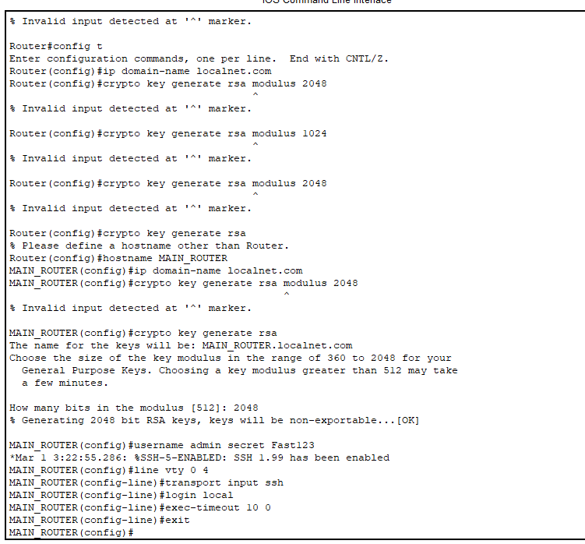
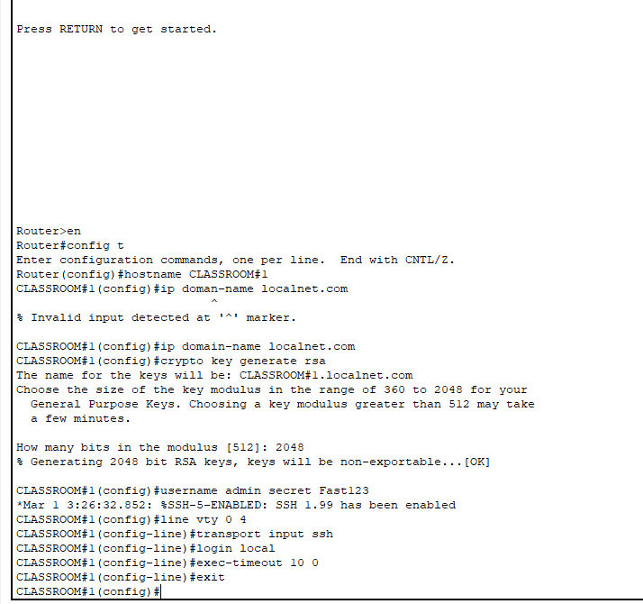

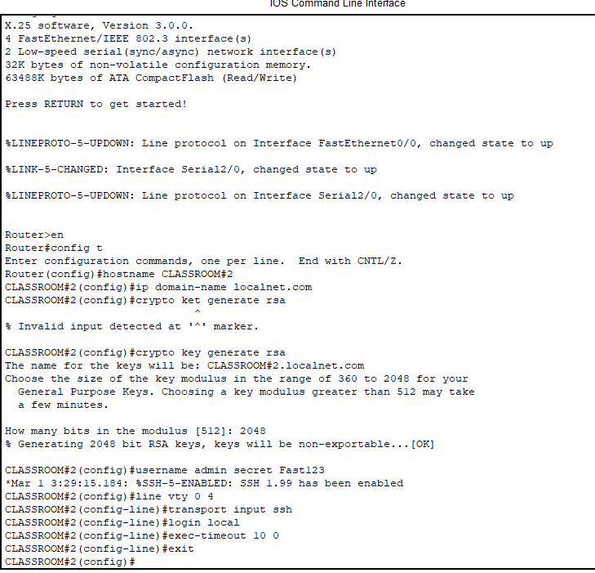

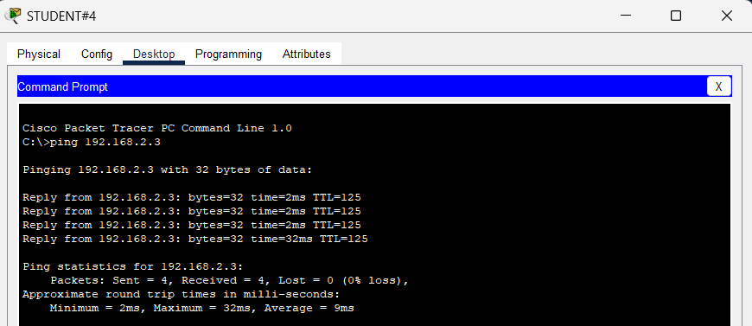

Classroom 1
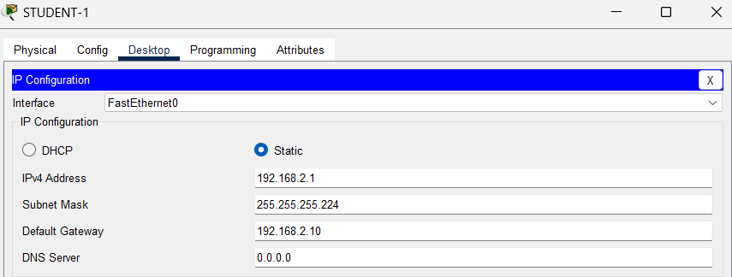
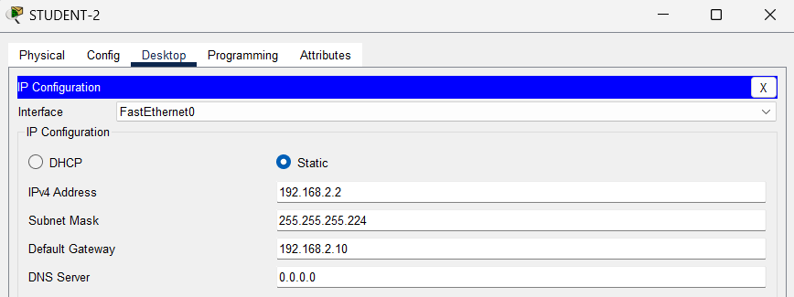
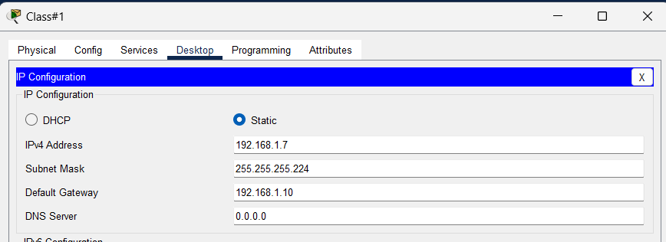
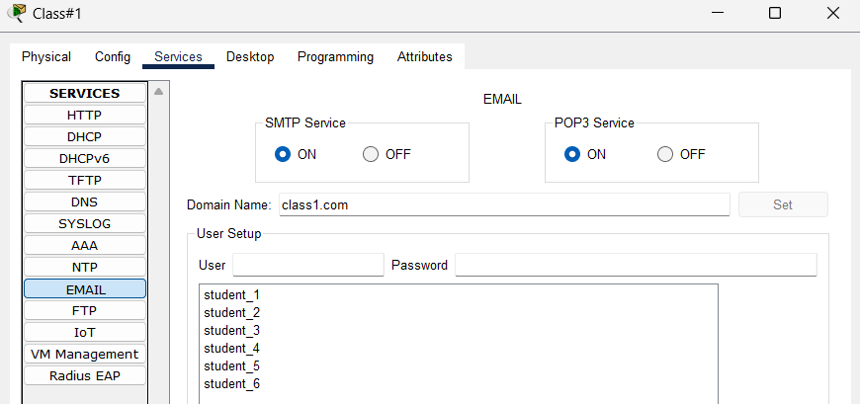

Classroom 2
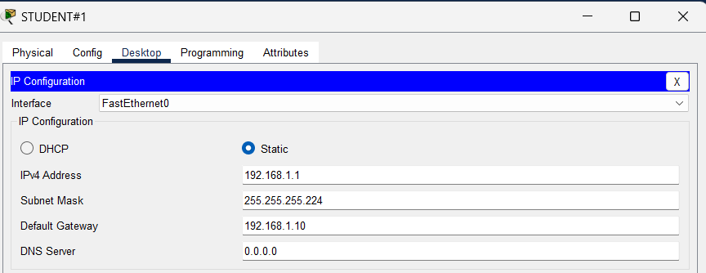
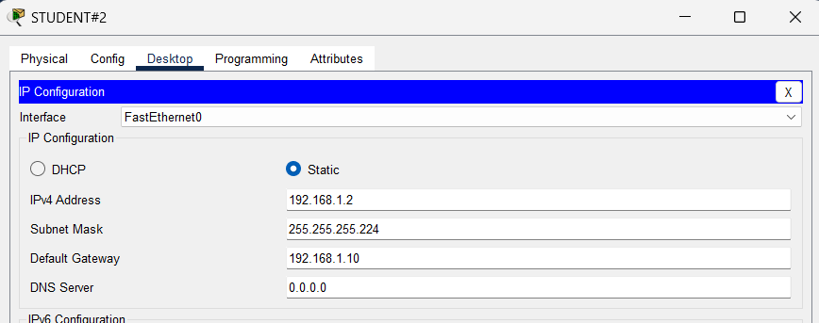
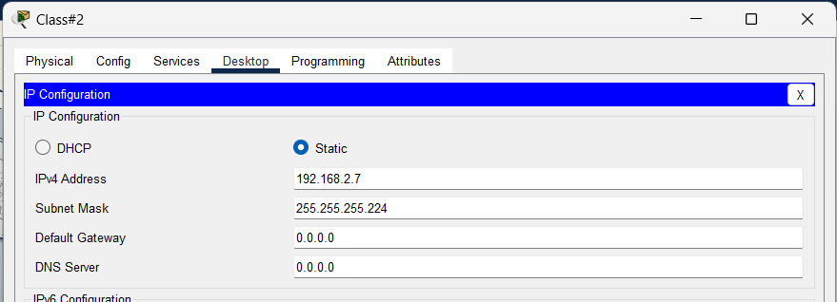
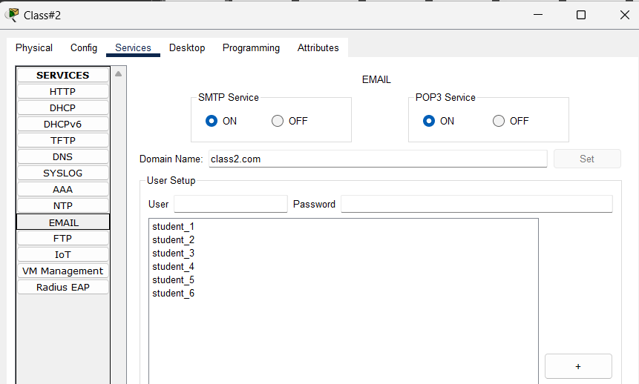

Admin
